Pomiary na macierzach : [4, 8, 16, 32, 64, 128, 256, 512, 1024]

Sekwencyjne:
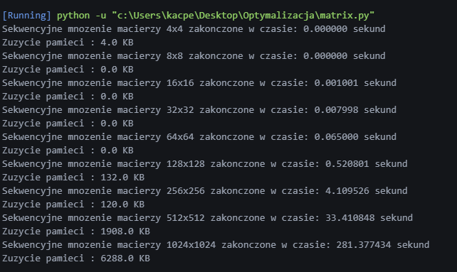

Rozproszone (1 watek)
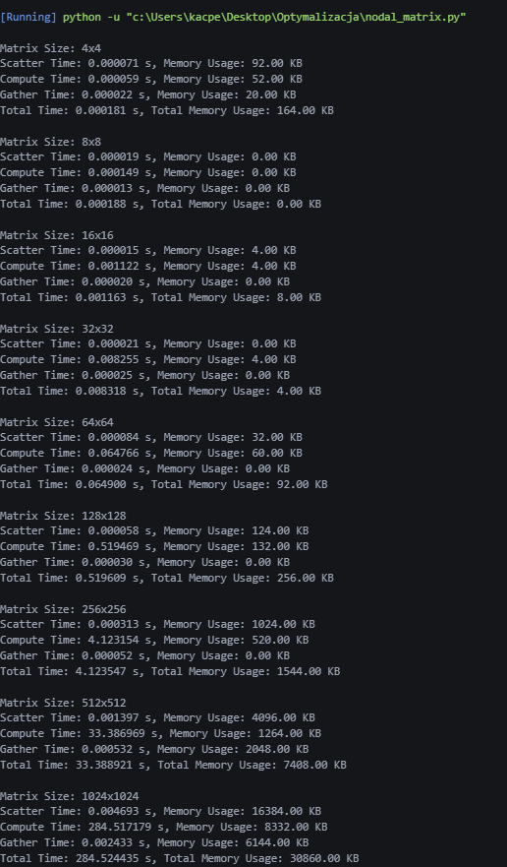

Rozproszone (4 watki)

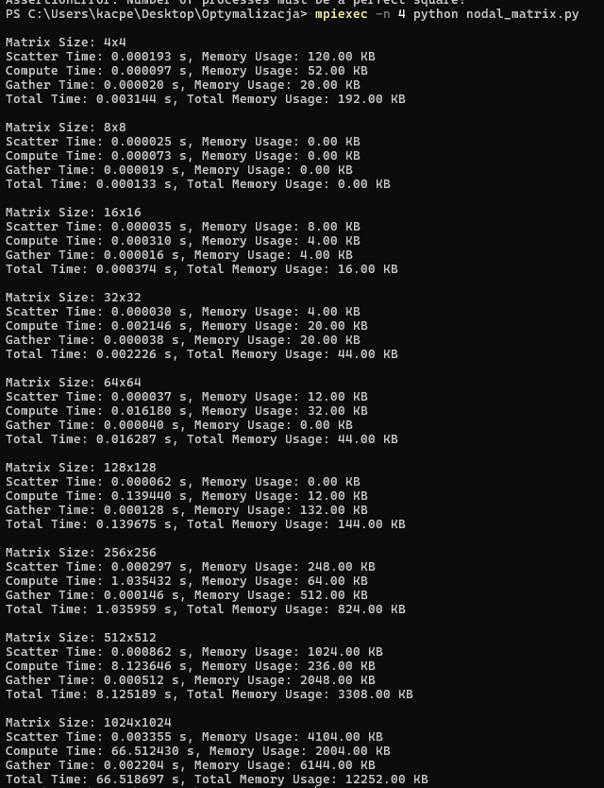

Rozproszone (16 watkow)

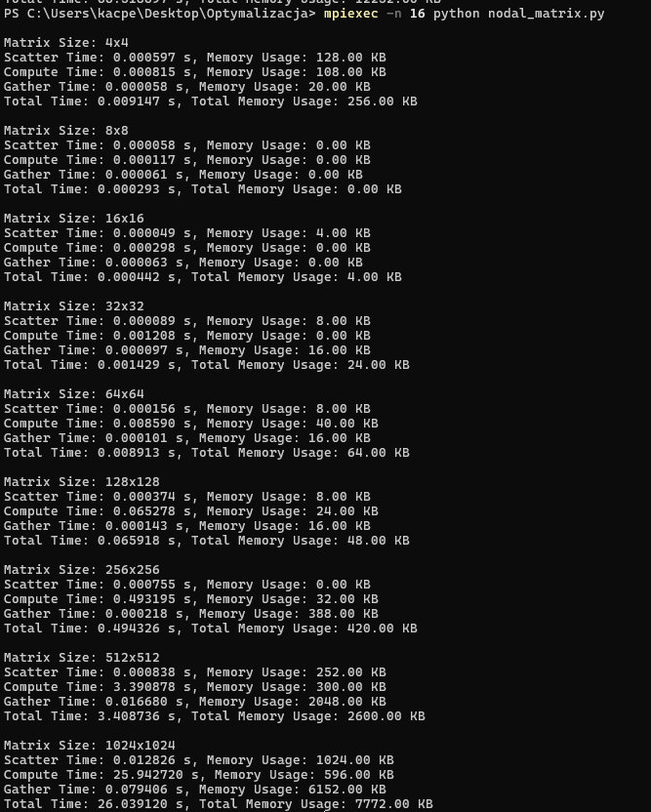

Porownanie wynikow:

1 watek:

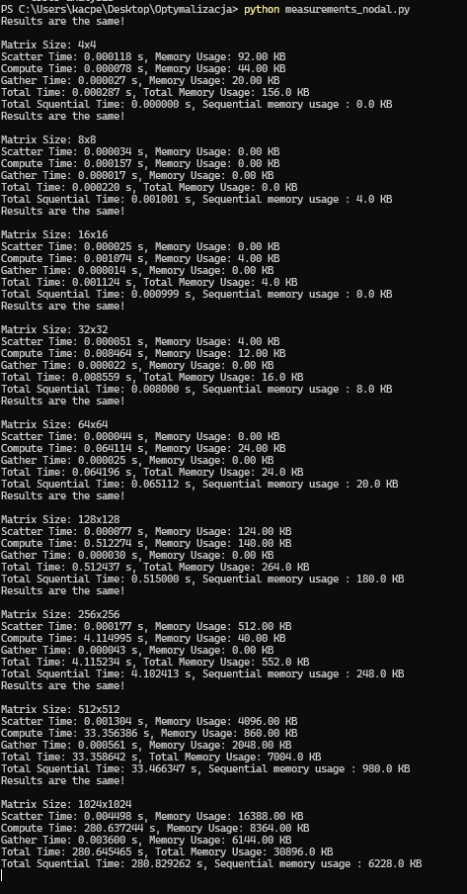

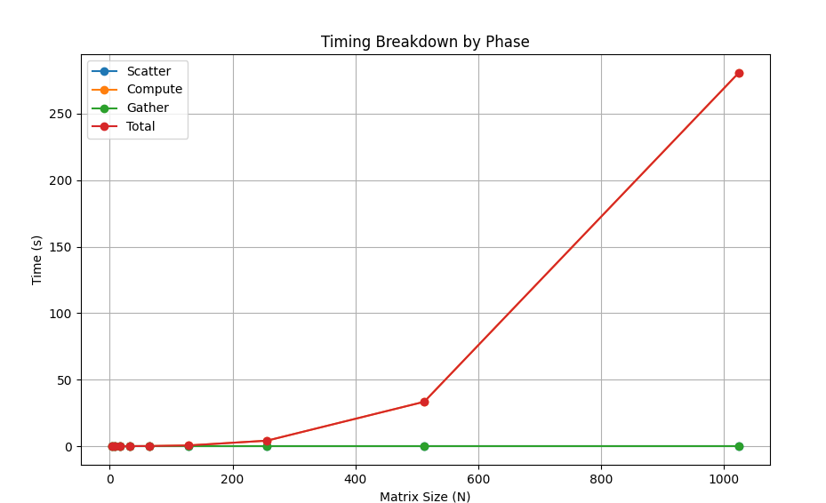
(MB, blad w kodzie, dzielilem przez 1024 w 2 miejscach)
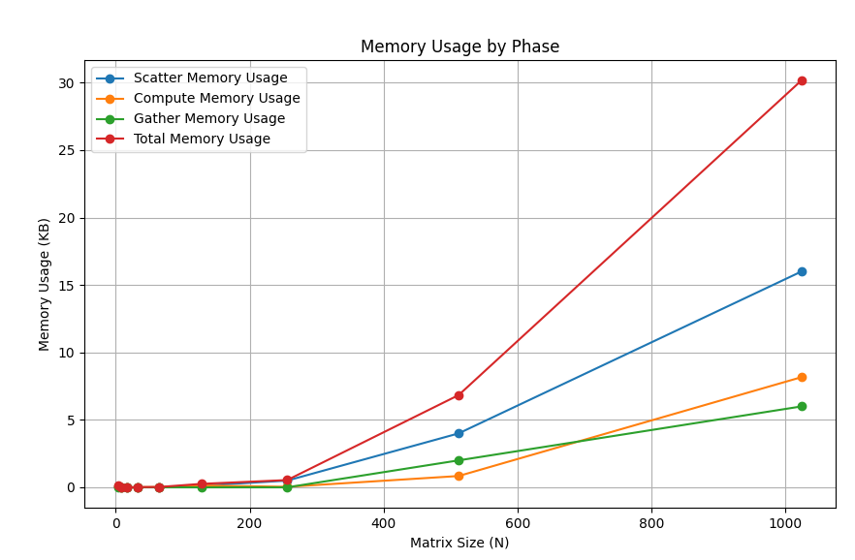
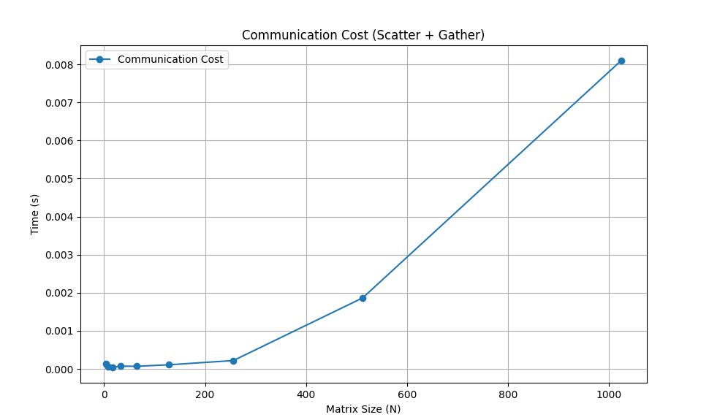

4 watki
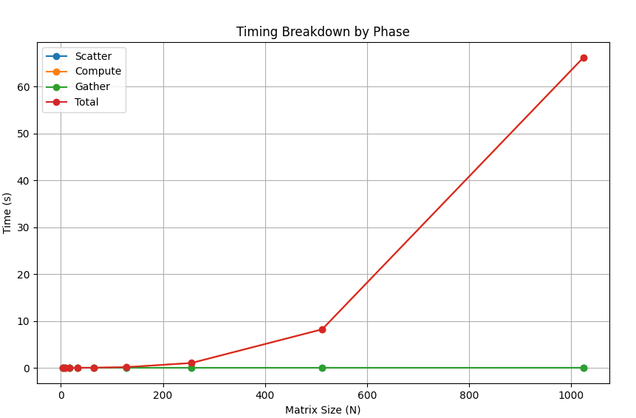
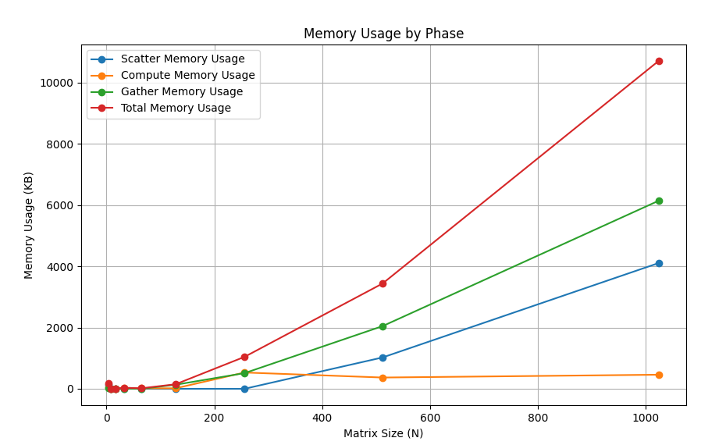
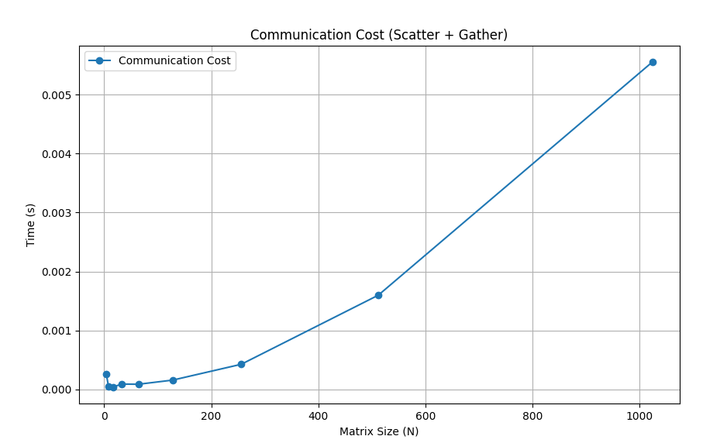

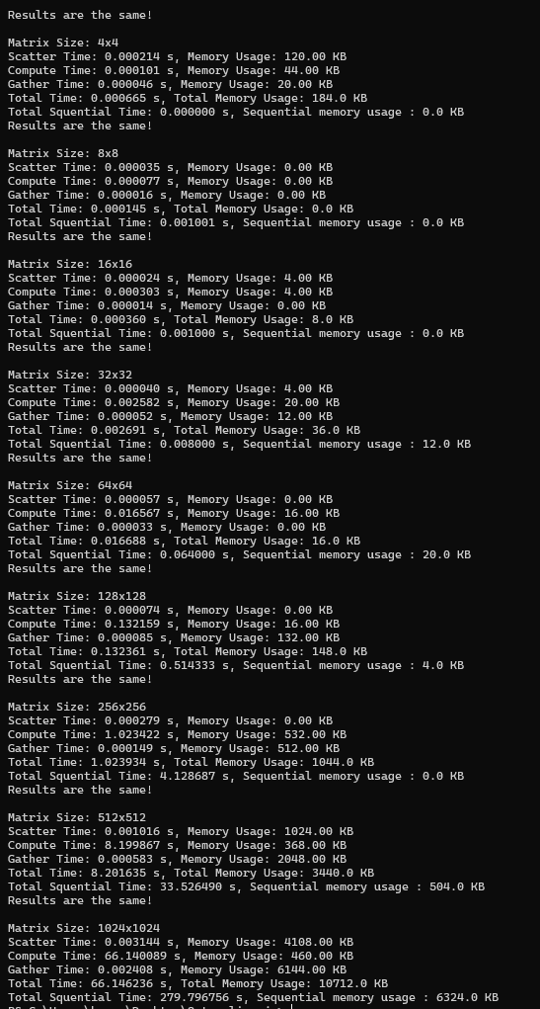
16 watkow
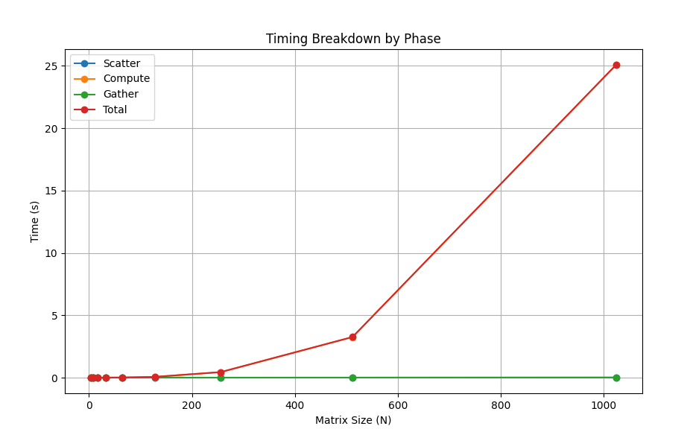
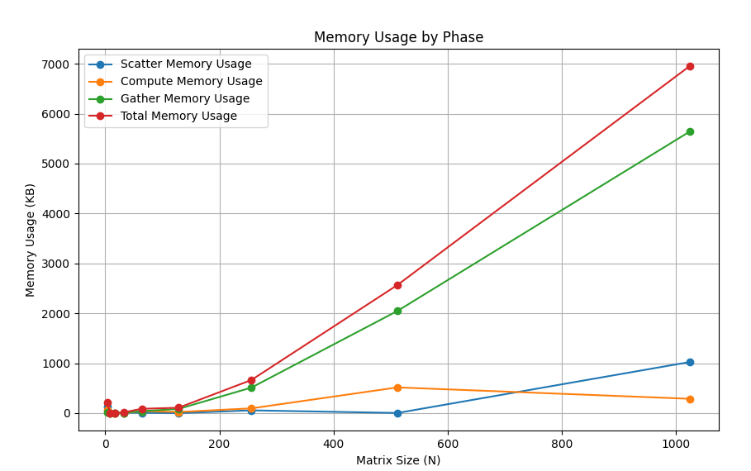

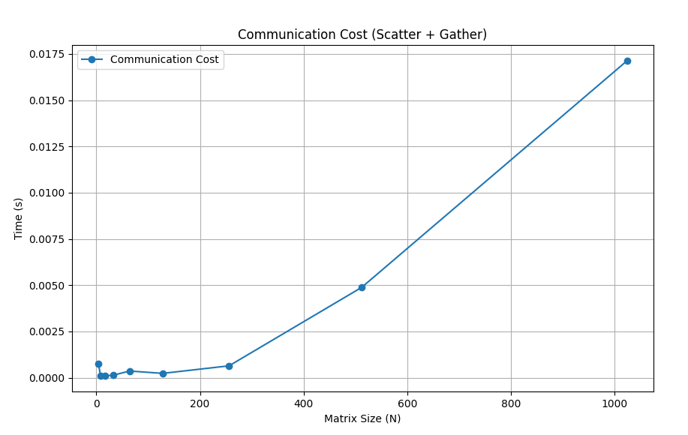
Results are different!
Max difference: 1.0692617368493176
Mean difference: 0.12001191707372927

Matrix Size: 4x4
Scatter Time: 0.000636 s, Memory Usage: 136.00 KB
Compute Time: 0.001078 s, Memory Usage: 64.00 KB
Gather Time: 0.000115 s, Memory Usage: 20.00 KB
Total Time: 0.009102 s, Total Memory Usage: 220.0 KB
Total Squential Time: 0.000000 s, Sequential memory usage : 0.0 KB
Results are different!
Max difference: 0.7766729686388931
Mean difference: 0.13906771954543357

Matrix Size: 8x8
Scatter Time: 0.000057 s, Memory Usage: 0.00 KB
Compute Time: 0.000145 s, Memory Usage: 0.00 KB
Gather Time: 0.000052 s, Memory Usage: 0.00 KB
Total Time: 0.000323 s, Total Memory Usage: 0.0 KB
Total Squential Time: 0.000527 s, Sequential memory usage : 0.0 KB
Results are different!
Max difference: 1.2982341956330288
Mean difference: 0.2030029880841948

Matrix Size: 16x16
Scatter Time: 0.000027 s, Memory Usage: 0.00 KB
Compute Time: 0.000358 s, Memory Usage: 0.00 KB
Gather Time: 0.000081 s, Memory Usage: 0.00 KB
Total Time: 0.000512 s, Total Memory Usage: 0.0 KB
Total Squential Time: 0.001553 s, Sequential memory usage : 0.0 KB
Results are different!
Max difference: 1.94102376502964
Mean difference: 0.24765736740127167

Matrix Size: 32x32
Scatter Time: 0.000049 s, Memory Usage: 8.00 KB
Compute Time: 0.001188 s, Memory Usage: 0.00 KB
Gather Time: 0.000084 s, Memory Usage: 8.00 KB
Total Time: 0.001393 s, Total Memory Usage: 16.0 KB
Total Squential Time: 0.008533 s, Sequential memory usage : 12.0 KB
Results are different!
Max difference: 4.06222610668155
Mean difference: 0.38066186756602405

Matrix Size: 64x64
Scatter Time: 0.000236 s, Memory Usage: 8.00 KB
Compute Time: 0.009367 s, Memory Usage: 40.00 KB
Gather Time: 0.000127 s, Memory Usage: 40.00 KB
Total Time: 0.009914 s, Total Memory Usage: 88.0 KB
Total Squential Time: 0.067414 s, Sequential memory usage : 4.0 KB
Results are different!
Max difference: 5.304364234194935
Mean difference: 0.5265021800014229

Matrix Size: 128x128
Scatter Time: 0.000098 s, Memory Usage: 0.00 KB
Compute Time: 0.060375 s, Memory Usage: 24.00 KB
Gather Time: 0.000139 s, Memory Usage: 84.00 KB
Total Time: 0.061442 s, Total Memory Usage: 108.0 KB
Total Squential Time: 0.510001 s, Sequential memory usage : 132.0 KB
Results are different!
Max difference: 8.623787578736078
Mean difference: 0.7547608589947449

Matrix Size: 256x256
Scatter Time: 0.000450 s, Memory Usage: 56.00 KB
Compute Time: 0.444146 s, Memory Usage: 96.00 KB
Gather Time: 0.000194 s, Memory Usage: 512.00 KB
Total Time: 0.445749 s, Total Memory Usage: 664.0 KB
Total Squential Time: 4.169017 s, Sequential memory usage : 444.0 KB
Results are different!
Max difference: 12.704605150719786
Mean difference: 1.062523514212506

Matrix Size: 512x512
Scatter Time: 0.001143 s, Memory Usage: 4.00 KB
Compute Time: 3.252873 s, Memory Usage: 516.00 KB
Gather Time: 0.003742 s, Memory Usage: 2048.00 KB
Total Time: 3.259632 s, Total Memory Usage: 2568.0 KB
Total Squential Time: 33.266242 s, Sequential memory usage : 860.0 KB
Results are different!
Max difference: 17.83027469115831
Mean difference: 1.5077517020711557

Matrix Size: 1024x1024
Scatter Time: 0.012611 s, Memory Usage: 1024.00 KB
Compute Time: 25.067348 s, Memory Usage: 288.00 KB
Gather Time: 0.004522 s, Memory Usage: 5640.00 KB
Total Time: 25.087863 s, Total Memory Usage: 6952.0 KB
Total Squential Time: 278.487080 s, Sequential memory usage : 6312.0 KB

[64, 128, 256, 512, 1024]
64 watki
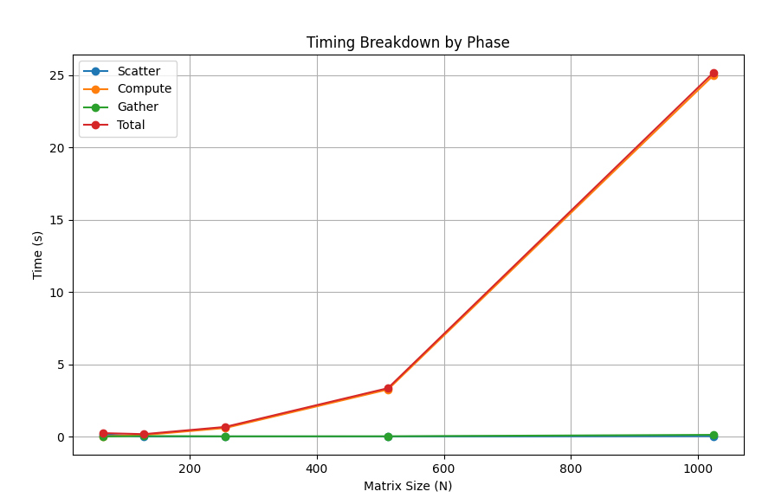
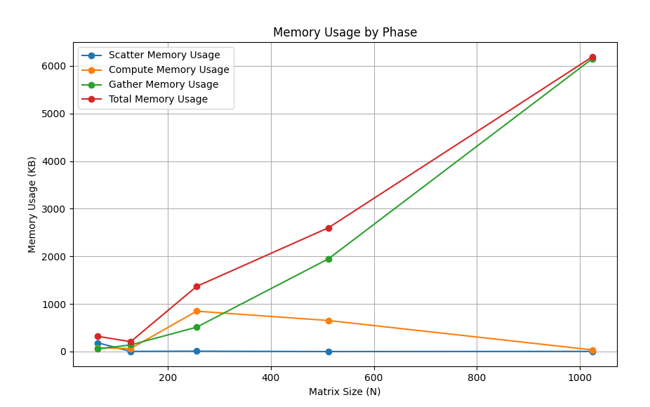

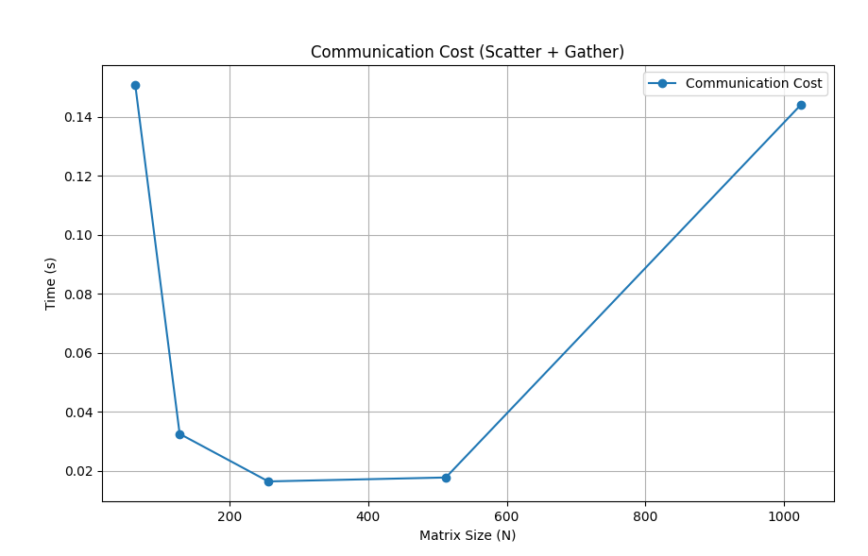

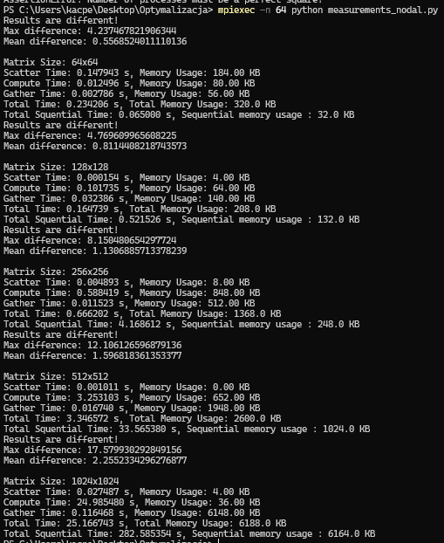

CZESC DRUGA

Liczba procesow : 1

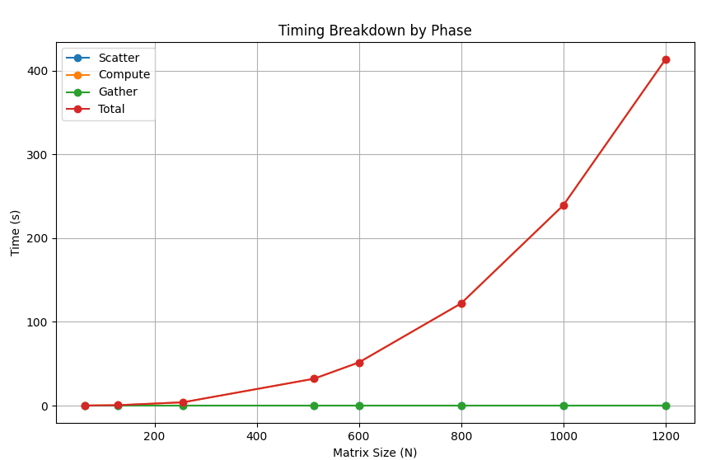

Liczba procesow : 4

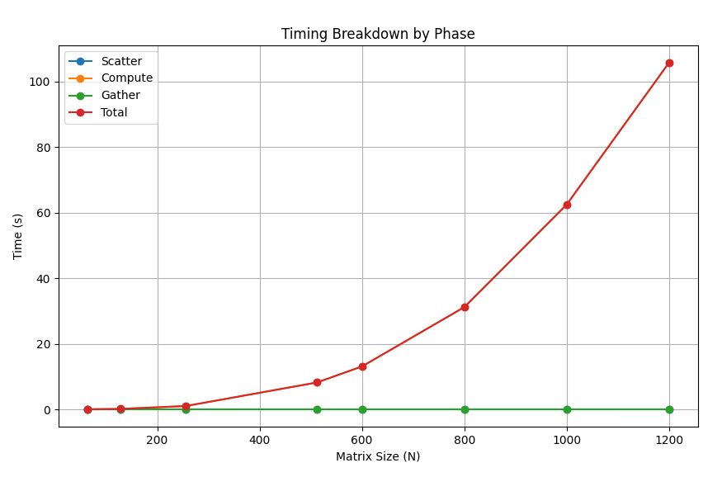
DANE : num_processes = [1, 4, 16, 64] input_sizes = [64, 128, 256, 512, 600, 800, 1000, 1200]
Liczba procesow : 16

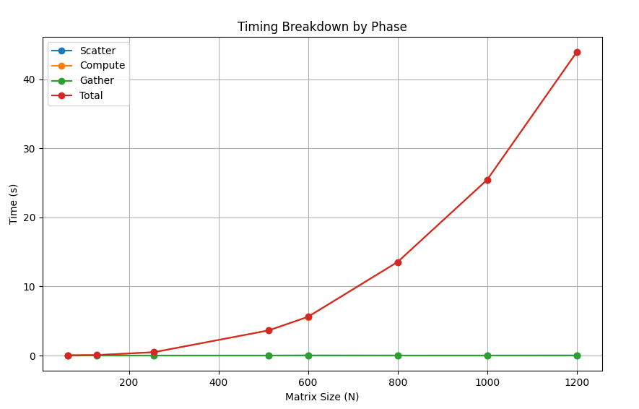

Liczba procesow : 64
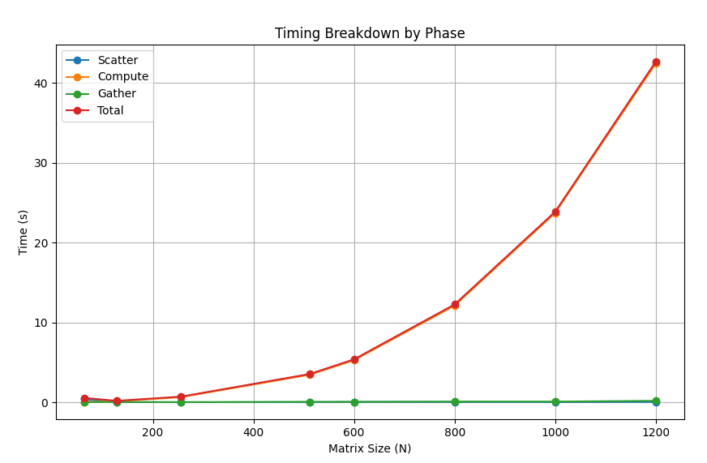

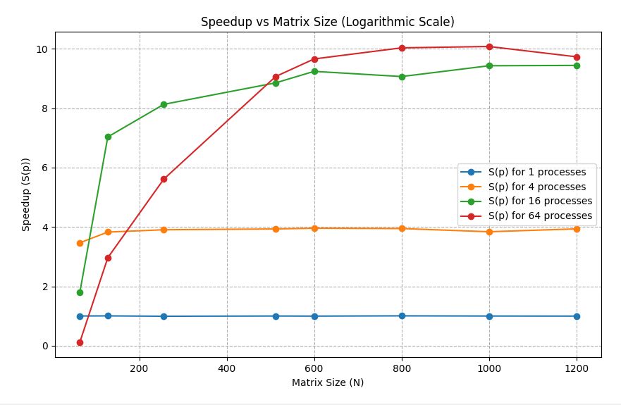
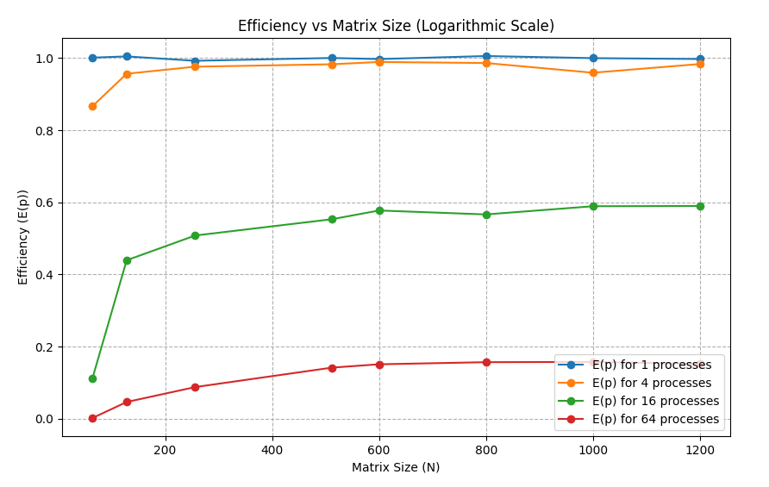

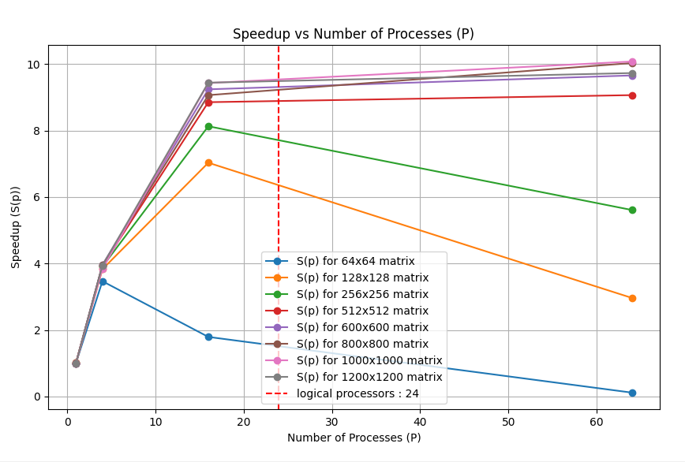
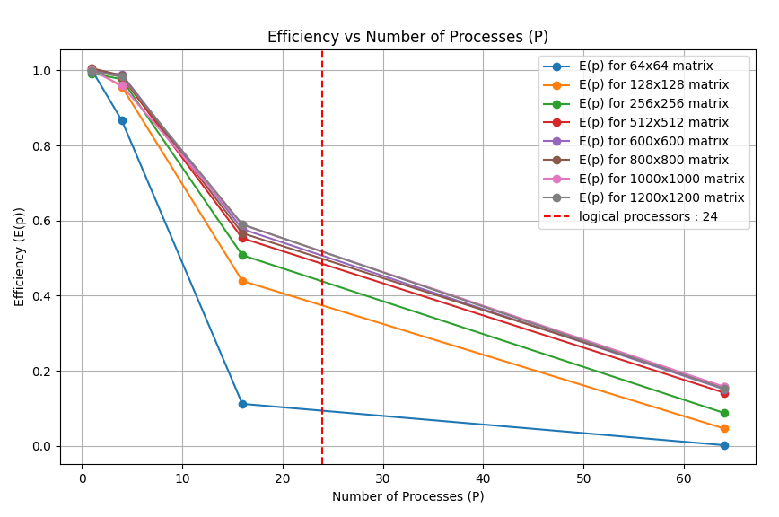
OS Y na LOG

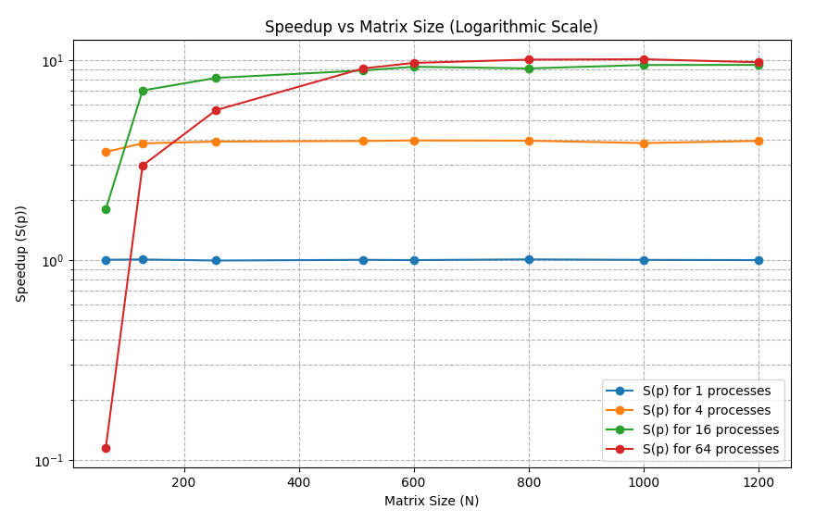
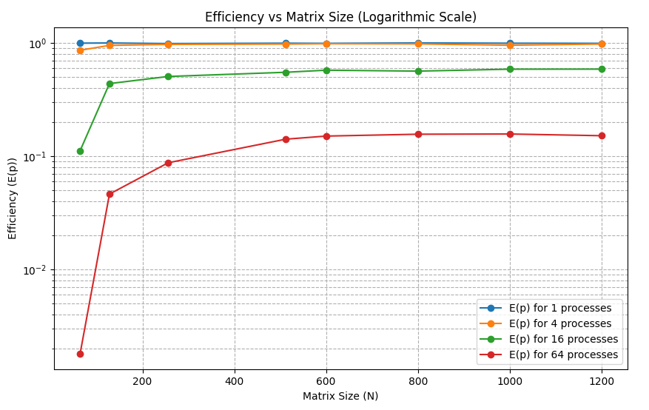

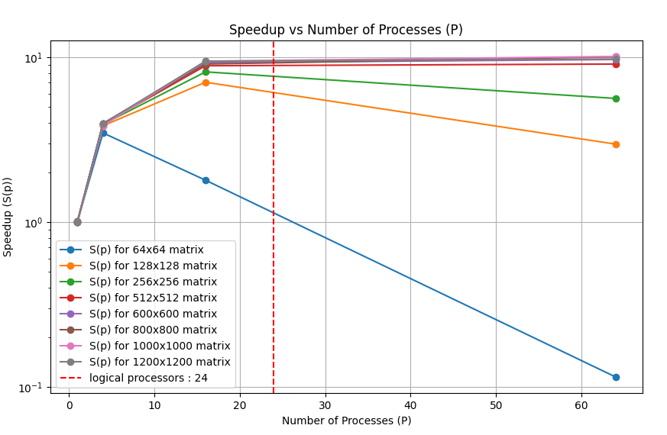
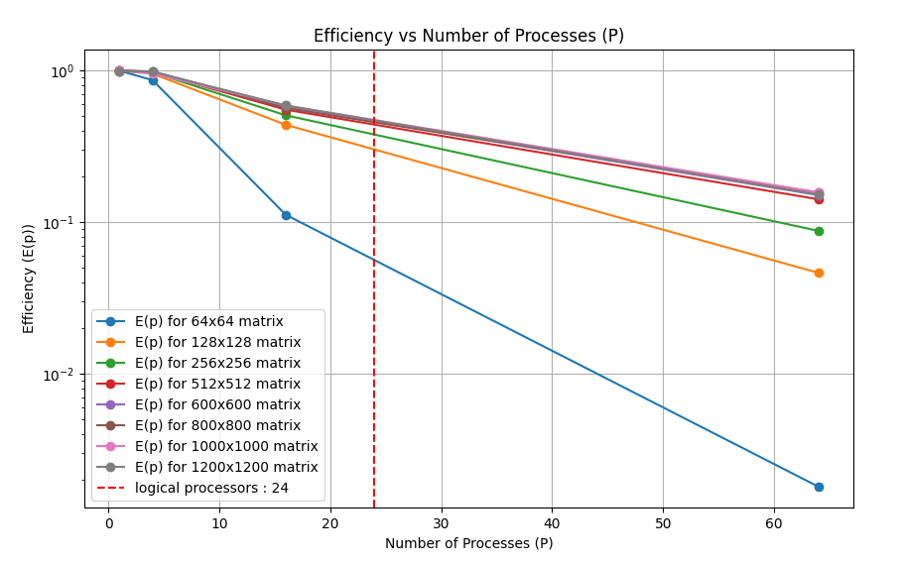
Dodano wiecej punktow pomiarowych :
input_sizes = [120, 240, 360, 480, 600, 720, 840, 960, 1200, 1320]
num_processes = [1, 4, 16, 25, 36, 64]

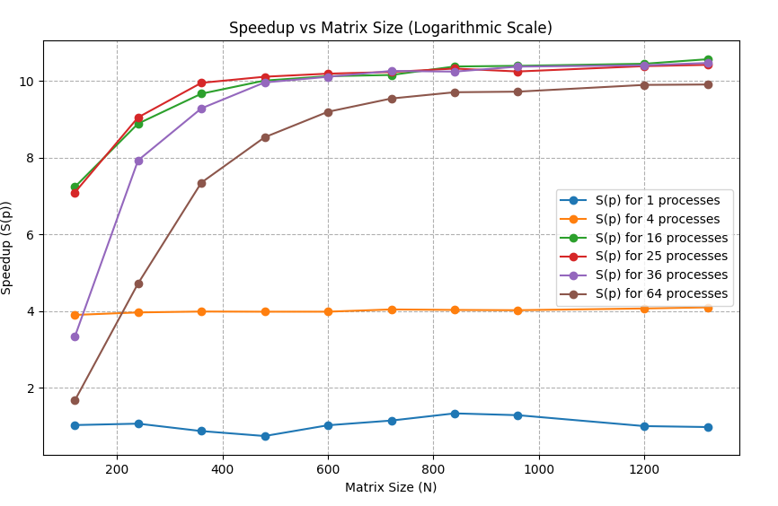
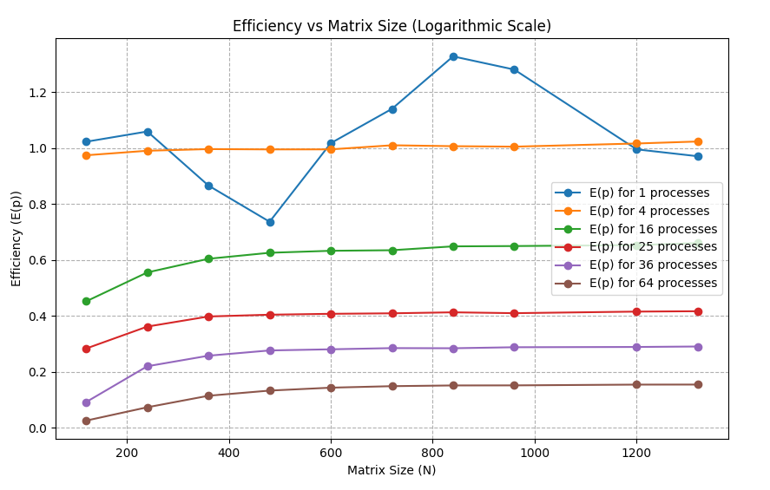
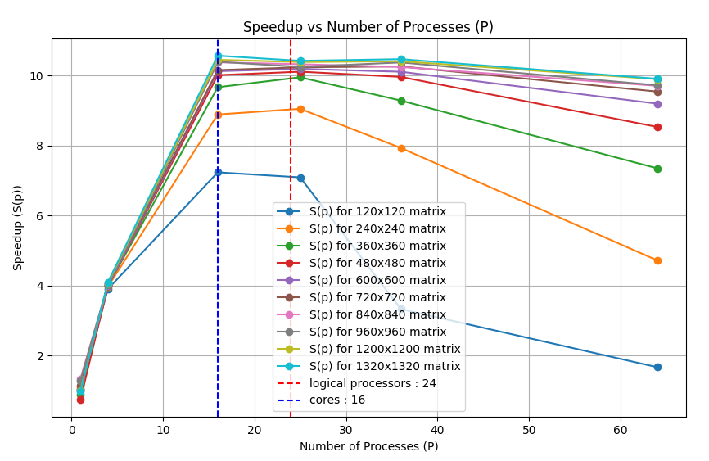
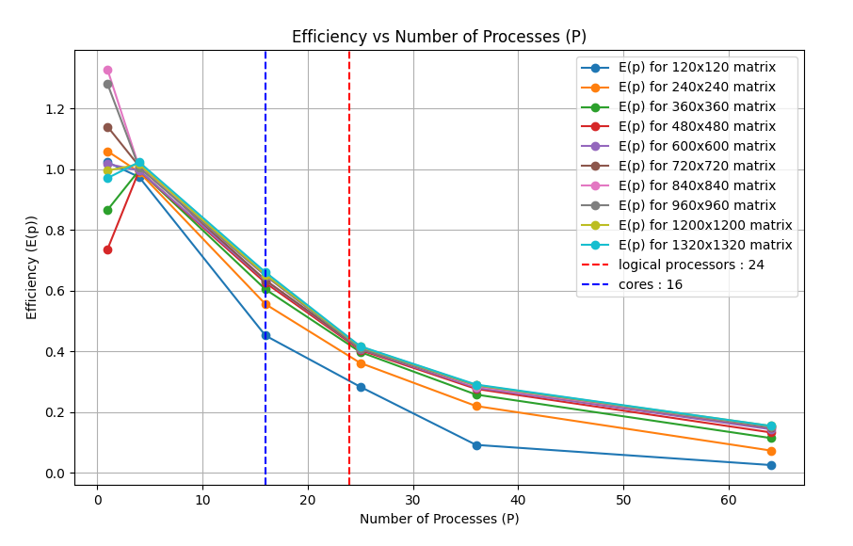
OS Y na LOG




